Users in the community “Political Compass Memes,” found on Reddit.com, self-identify their political leanings as belonging to one of 10 categories on the political compass (Figure 1).[1] The compass’ two axes represents two political scales: left to right, and authoritarian to libertarian. As an example, a user presenting their political ideology as “authoritarian” and “left” would state they are in the top left quadrant. However, not all users fall into a singular quadrant. Some users identify themselves as centrists, while others simply call themselves “left” or “authoritarian” if they are central to one of axes. Based on x-axis orientation, we condense the compass into three nominal categories: Left, Center, and Right (Figure 1).

The Pushshift dataset contains nearly all user comment and post data from the social media site, Reddit, from its inception in 2005 until today (Baumgartner et al. 2020). We use Pushshift data from June to December 2019 to identify users who have selected a political compass identity. We then use the user’s comment history to identify which other Reddit communities they have commented. A given comment’s “score” is used to determine how well it was received by the given community.

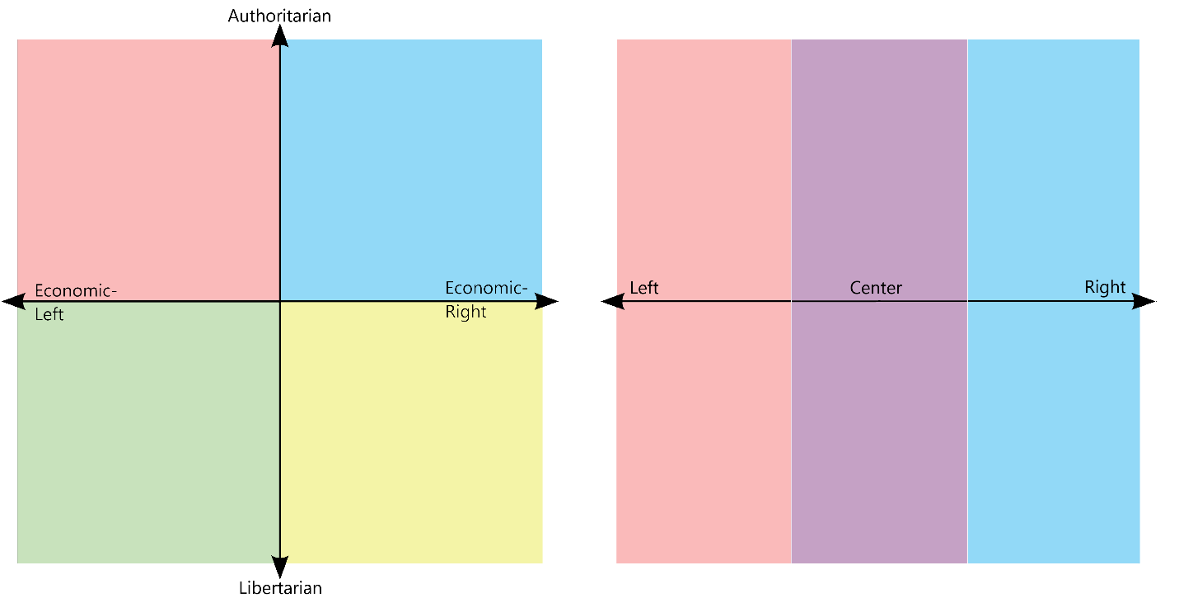

REFERENCES

Baumgartner, Jason, Savvas Zannettou, Brian Keegan, Megan Squire, and Jeremy Blackburn. 2020. “The Pushshift Reddit Dataset.” *Proceedings of the International AAAI Conference on Web and Social Media* 14:830–39.

1. Users can identify themselves as any one of the following groups: Left, Libertarian Left, Authoritarian Left, Centrist, Authoritarian, Libertarian, Right, Libertarian Right, Authoritarian Right, or None.